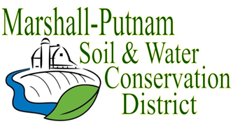
BOARD MEETING AGENDA
April 13th, 2023 – 9am
In Person – USDA Service Center – 1511 University Ct. Henry

WELCOME/ROLL CALL

CALL TO ORDER
CALL FOR ADDITIONS TO AGENDA

MINUTES FOR APPROVAL: March 2023 board meeting
Employee Time Sheets for approval – March

COMMITTEE REPORTS
Financial Committee

FINANCES
Accounts Payable
Approval of ESC Cost share payments
Approval of financial reports
Budget review

OLD BUSINESS
Monthly COVID update – Ends May 11, 2023

NEW BUSINESS
Marshall-Putnam River Conservancy Meeting
Fish Sales

CORRESPONDENCES STAFF REPORTS
Resource Conservationist
Administrative Coordinator
NEXT MEETING: NRCS-District Con/Soil Con
May 11th, 2023 @ 9am

