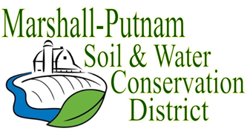
BOARD MEETING AGENDA
August 10th, 2023 – 9am
In Person – USDA Service Center – 1511 University Ct. Henry

WELCOME/ROLL CALL

CALL TO ORDER
CALL FOR ADDITIONS TO AGENDA

MINUTES FOR APPROVAL: July 2023 board meeting
Employee Time Sheets for approval – July

COMMITTEE REPORTS
Financial Committee

FINANCES
Accounts Payable
Approval of ESC Cost share payments
Approval of financial reports
FY24 New Budget – 2nd reading

OLD BUSINESS
2023 Wetland Field Day – 2nd round – August 17th 4-7p

NEW BUSINESS
Banking info – CD information
Jill/Stacy Classes
Mutual Aide agreement with Bureau Co SWCD
Hopkins Assc. for audit.

CORRESPONDENCES STAFF REPORTS
Resource Conservationist
Administrative Coordinator
NEXT MEETING: NRCS-District Con/Soil Con
Sept 14th, 2023 @ 9am

