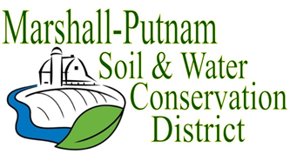
BOARD MEETING AGENDA
February 9th, 2023 – 9am
In Person – USDA Service Center – 1511 University Ct. Henry

WELCOME/ROLL CALL

CALL TO ORDER
CALL FOR ADDITIONS TO AGENDA
MINUTES FOR APPROVAL: January 2023 board meeting
Employee Time Sheets for approval – January

COMMITTEE REPORTS
Financial Committee

FINANCES
Accounts Payable
Approval of ESC Cost share payments
Approval of financial reports
Budget review

OLD BUSINESS
Monthly COVID update

NEW BUSINESS
Elections!! Stop and vote if you have not already!
Director Training – March 1st
Goal Day Review
In person Lobby Day – Wednesday, March 8th – Springfield, IL
Wetland Field Day Date

CORRESPONDENCES STAFF REPORTS
Resource Conservationist
Administrative Coordinator
NEXT MEETING: NRCS-District Con/Soil Con
March 9th, 2023 @ 9am

