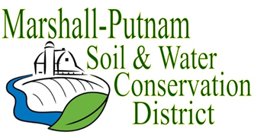

BOARD MEETING AGENDA
January 12th, 2023 – 9am
In Person – Marshall-Putnam SWCD – 1511 University Ct. Henry, IL

WELCOME/ROLL CALL

CALL TO ORDER
CALL FOR ADDITIONS TO AGENDA
MINUTES FOR APPROVAL: December 2022 board meeting
Employee Time Sheets for approval – December

COMMITTEE REPORTS
Financial Committee
Personnel Committee – No report

FINANCES
Accounts Payable – Action needed
Approval of ESC Cost share payments – Action needed
Approval of financial reports – Action needed
Budget review

OLD BUSINESS
Monthly COVID update

EXECUTIVE SESSION

NEW BUSINESS
Elections – Nominating Committee Report
Thank you from the family of John (Jack) Johnson – MP River Conservancy
Action on Executive Session – if needed
Staff Reports – NRCS

CORRESPONDENCES

NEXT MEETING:

February 9th, 2023

