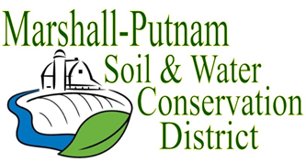
BOARD MEETING AGENDA
July 13, 2023 – 9am
In Person – USDA Service Center – 1511 University Ct. Henry

WELCOME/ROLL CALL

CALL TO ORDER
CALL FOR ADDITIONS TO AGENDA

MINUTES FOR APPROVAL: June 2023 board meeting
Employee Time Sheets for approval – June

COMMITTEE REPORTS
Financial Committee
Personnel Committee

FINANCES
Accounts Payable
Approval of ESC Cost share payments
Approval of financial reports
Budget review end FY23
FY24 New Budget – review only

OLD BUSINESS
2023 Wetland Field day - recap

NEW BUSINESS
Summer Conference 2023 – voting delegate.
AISWCD info on Bylaw changes/new Bills
Banking info – FDIC, CD’s

CORRESPONDENCES STAFF REPORTS
Resource Conservationist
Administrative Coordinator
NEXT MEETING: NRCS-District Con/Soil Con
August 10, 2023 @ 9am

