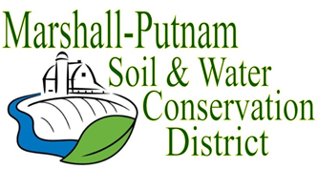
BOARD MEETING AGENDA
March 16th, 2023 – 9am
In Person – USDA Service Center – 1511 University Ct. Henry

WELCOME/ROLL CALL

CALL TO ORDER
CALL FOR ADDITIONS TO AGENDA

Grant Hammer – AISWCD – Budget, Quarterly boards, etc

MINUTES FOR APPROVAL: February 2023 board meeting
Employee Time Sheets for approval – February

COMMITTEE REPORTS
Financial Committee

FINANCES
Accounts Payable
Approval of ESC Cost share payments
Approval of financial reports
Budget review

OLD BUSINESS
Monthly COVID update – Ends May 11, 2023

NEW BUSINESS
Jill – Service Award
Elections results – Board reorganization
Statement of Econ. Interest
PFC Cost List Approval
Envirothon
IDOA Regional Meeting recap
Goal Day Review

CORRESPONDENCES STAFF REPORTS
Resource Conservationist
Administrative Coordinator
NEXT MEETING: NRCS-District Con/Soil Con
April 13th, 2023 @ 9am

